Also Cheap Arduino Wireless Communications: These are the 315mhz transmitters/receivers

and probably would work very well for use in a homing robot system:

<http://www.glacialwanderer.com/hobbyrobotics/?p=291>

Homing Robot (Arduino)

<http://www.robowarner.com/robot/rdfbotarduino>

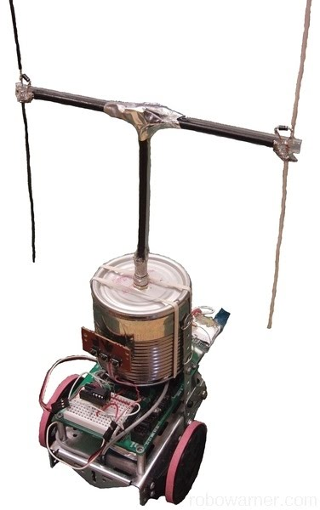

It looks a little strange - but what it is is a boe-bot chassy, with arduino uno, bread board, and antenna, and how it works is explained in more detail on the site - but basicly it spins in a circle until it finds the strongest signal - it then points itself toward that source, and moves to it and stops when it gets to it.

Pretty simple. but not real practical for the type of robot I want to build. The maker of this is using off the shelf FRS radios which are UHF, in the 460mhz range - the problem I see is if someone is on the same channel. and it’s just a carrier wave being transmitted.

For that reason I think the 315mhz low powered one would work better - I also think you probably could transmit a beacon number or some other id so the robot wouldn’t get confused if someone else was also transmitting in the 315mhz band.

Here is some more info on this robot:

<http://www.robowarner.com/sciencefair/homingbots>

And what his project was based off of:

<http://theleggios.net/wb2hol/projects/rdf/tdoa1.htm>

(Simple Time-Difference-OF-Arrival RDF)

This is not new, Ham’s have been using these type of antennas for “Fox Hunting” for decades now.

<https://en.wikipedia.org/wiki/Transmitter_hunting>

<http://www.arrl.org/direction-finding>

In detail (and fun) “What is Fox Hunting” video (36 mins)

<https://www.youtube.com/watch?v=tQ8gNHAFXXY>

Back in the Mid 90s there was a system called Lojack - and police cars were all (or most) equipped with 4 extra antennas to find cars that had the Lo-Jack tracker on them.

The Lo-Jack company is still around, and I think they still use a system like that, but it probably also includes cell and GPS location now.

But if you see a Police car with 4 antenna in a square on the roof, that car is equipped to find cars that have lo-jack on them.

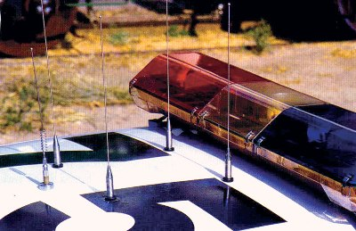

The above is a Lo-Jack receive antenna array.

With out going into too much detail this works by looking at the phase and time difference the transmitted wave hits the antennas, it can then calculate which of the antenna got the signal first, and point you in the direction of the signal.

Using this for navigation, the front of the car would be 0 degrees, if the wave hits both the front antennas at the same time, the source is directly in front of you. (This is called relative navigation the other type would be true navigation - which uses a compass and true north is always the reference), If the signal would hit both the antennas on the right, the source would be 90 degrees relative to the front of the vehicle, if the wave would hit both the rear antennas at the same time, the source would be 180 degrees relative to the front of the vehicle, and of course if the wave was to hit the two left antennas at the same time, the source would 270 degrees relative to the front of the vehicle (or -90 depending on how you setup your navigation)

The wave hitting all four at the same time would mean you are on top of the source (very little time differences). The wave hitting any of the antennas at different times would place the “dot” on the board closest to the number of degrees the signals are out of phase. In the picture below it’s calibrated for 22.5 degrees (I’m not sure why, it could be that is how the math worked out for the frequencies they are using, I’m not sure.) When you navigate toward the source, you’ll notice that if the source is stationary it should now be in front of you Zero degrees, if you turn again, or if the source starts to move, the lights will start moving, it all relative to the front of your vehicle. Sooner or later you’ll get on top of it, or get close enough that (either all the LEDs will be on, or none of the LEDs will be on depending on how you have your system setup) Meaning you’ve found it.

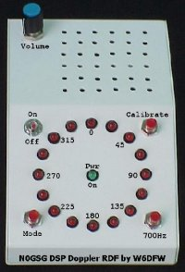

It’s a very sensitive system.

Lo-Jacks do the same thing, but to keep things simple for the officers, that system usually gives bearings (not a “radar” type screen) and arrows pointing in the direction they need to go.

Something like this could be used on the robot, It would have 4 sensitive antennas, and would not need to spin around until it got a signal. This is always an option for the robot, it would take a lot more to setup and get working correctly. And you’ll need to get power to your transmitter. But it would work.

These systems have been around for a very long time, During WWII radio direction finding was a special skill that was used to find hidden enemy transmitters (on both sides)